Music Theory I – Chapter 1 & 2 Test Name_________________________________
Mrs. Marquez-Grewatz

Part 1: True/False – Indicate whether each statement is True (T) or False (F). If the statement is False, correct the statement to make it true.

1. _____ The root of a chord is always the lowest note. (False – it may not be lowest note)

2. ______ A Pentatonic scale is a five-tone scale. (True)

3. ______ The time signature 6/8 is considered a simple duple meter. (False – compound duple)

4. ______ The interval between G and Bb is a minor third. (True)

5. ______ Dots may only be used for notes, not rests. (False – they may used for both)

Part 2: Multiple Choice – Circle the letter next to the correct answer of each question.

6. The dynamic mezzo piano can best be described as: (B)
a. Very soft
b. Moderately soft
c Gradually become softer
d. soft

7. A sharp sign (#) alters the given note by: (A)
a. raise by one half-step
b. lower by one half-step
c. raise by two half-steps
d. none of the above

8. A natural minor scale with a raised sixth degree is also known as: (A)
a. Dorian Scale
b. Mixolydian Scale
c. Ionian Scale
d. Phrygian Scale

9. The fourth scale degree of a diatonic scale can be referred to as: (C)
a. Subtonic
b. Submediant
c. Subdomiant
d. Mediant

10. A caesura written in your music means: (C)
a. A grand pause
b. Watch the director
c. Both a and b
d. None of the above

Part 3: Matching – Match each key signature to the appropriate major scale. Each will only be used once.
G. 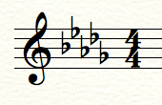

H. 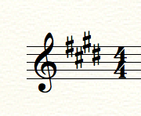

I. 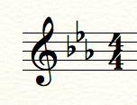

J. 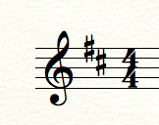

K. 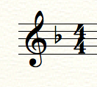

L. 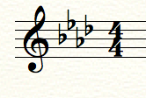
A. 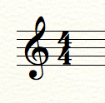

B.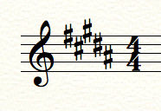

C. 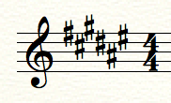

D. 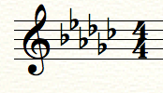

E. 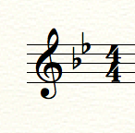

F. 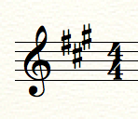
9. _____ Bb Major (E)

M. 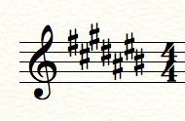

N. 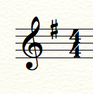

O. 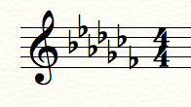

10. _____ A Major (F)

11. _____ Gb Major (D)

12. _____ D Major (J)

13. _____ Ab Major (L)

14. _____ G Major (N)

15. _____F# Major (C)

16. _____ Cb Major (O)

17. _____ C# Major (M)

18. _____ Eb Major (I)

19. _____ E Major (H)

20. _____ B Major (B)

21. _____ F Major (K)

22. _____ Db Major (G)

23. _____ C Major (A)

Part 4: Short Answer – Respond to each of these questions using complete sentences.

24. What is meant when notes are said to be enharmonically equivalent?
Sample Answer: Enharmonic equivalents are tones that have the same pitch, but different letter names (ex. F sharp and G flat.)

25. What is an interval?
Sample Answer: An interval is the relationship between two tones. Intervals are named by the number of diatonic notes that can be contained within them.

Part 5: Essay – Respond to the question using complete sentences. Write at least one full paragraph using three sentences at a minimum.

26. What is a cadence? Give at least three examples of a cadence.

Sample Answer:

A harmonic cadence is a progression of two chords that concludes a phrase, section, or piece of music. An example of three different cadences would be: half, authentic, and plagal. A half cadence occurs when the harmonic elements of a phrase end on the dominant of the key. An authentic cadence is the resolution of the dominant to the tonic. When a phrase approaches the tonic with the subdominant, a plagal cadence is formed.

